ANNOUNCEMENTS
VISITORS: Please introduce yourself to Pastor Juhee. We are glad you were able to join us today!

WORSHIP SERVICES – view on our Facebook page and on YouTube!

HAVEN YOUTH BASKETBALL – New Season has started! Wed. 8 to 14 year olds – 5:30-7pm, 15 to 17 year olds – 7-9pm.

VISITATION – Pastor Juhee is doing visitation. If you would like a visit, let her know. Call Pastor Juhee at 404-697-7496.

* * * * * * * * * * * * * * * * * * * * * * * * * * * * * * * * * * * * * * * * * * * * * *
Coffee hour SUSPENDED until further notice!
* * * * * * * * * * * * * * * * * * * * * * * * * * * * * * * * * * * * * * * * * * * * * *

Birthdays
Lemuel Fuller – 1/24 Samuel Bohlen – 1/25

Weekly PRAYER REQUESTS
Winkie Chrystie Jean James Steve & Debbie Bentz
George Glover Bob Mason John Gould
Rev. Althea Jackson

CELEBRATIONS AND CONCERNS: Call the church office or talk to Pastor Juhee and tell us your Celebrations and Concerns. We will share them with the church family so that we can STAY CONNECTED!!

If you have an emergency or an immediate need, call the office at 401-438-4911 or Pastor Juhee at 404-697-7496. We are here to help!
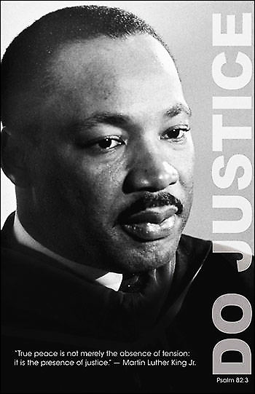
Haven United Methodist Church
Pastor ~ Juhee Lee
200 Taunton Avenue, East Providence, RI 02914
Phone: 401-438-4911/ Fax : 401-434-0289
www.havenumchurch.com ~ havenumchurch@yahoo.com
Pastor’s Office Hours: Mon, Tues & Sat - 10am–12pm and by appointment
Church Office Hours: Mon - Wed 9:30am-4:30pm, Thu. 9:30am-2:30pm

Morning Worship 9:30am January 17, 2021
Second Sunday after Epiphany

PRELUDE “A Morning Canticle” Martin
GREETING Pastor Juhee Lee
*MISSION STATEMENT: We are a haven for those who would seek to know God better while spreading the love of Jesus Christ.
*CALL TO WORSHIP Ministry Matters
L: People of God, who do you come to worship?
P: We come to worship the one true God.
L: How will you worship?
P: Not with words alone, but by living lives of justice and love.
L: Come, you who belong to God. Come, you who are foolish in the eyes of
the world.
P: Come and abide in God’s tent and in God’s heart, now and forever.
*INVOCATION (in unison) Ministry Matters
Loving God, we come this morning seeking to abide in your presence. Open our minds to your spirit of wisdom, that we may know how to live as your people. Open our hearts to your spirit of truth, that we may love all your people with a love that speaks of justice, kindness, and radical grace. May this time of worship be authentic and pleasing to you. Amen.
*RESPONSE HYMN “Majesty, Worship His Majesty” UMH 176
ANNOUNCEMENTS / CELEBRATIONS AND CONCERNS
HYMN “Alleluia” UMH 186
PASTORAL PRAYER/THE LORD’S PRAYER Pastor Juhee Lee
CHORAL RESPONSE TO PRAYER Hear Our Prayer, O Lord
Hear our prayer, O Lord, hear our prayer, O Lord;
Incline Thine ear to us, and grant us Thy peace. Amen.

VIRTUAL PASSING OF THE PEACE
L: The Peace of Christ be with you.
P: And also with you.
L: Let us radiate our light of love and peace toward each other.
HYMN “This Little Light of Mine” 1x
A TIME FOR ALL GOD’S CHILDREN Pastor Juhee Lee
WORSHIP IN GIVING “They’ll Know We Are Christians by Our Love” v. 1 & 2
Peter Scholtes Beverly Rathbun, organ
*DOXOLOGY
Praise God, from whom all blessings flow; praise him, all creatures
Here below; praise him above, ye heavenly host; praise Father,
Son, and Holy Ghost. Amen.
OFFERTORY PRAYER Pastor Juhee Lee
SCRIPTURE
Old Testament: Micah 6:1-8
L: This is the Word of God for the people of God.
P: Thanks be to God!
SERMON “Martin Luther King Jr. Celebration” Clarence Tucker
*CLOSING HYMN “For the Healing of the Nations” v. 1, 2, 4 UMH 428
*BENEDICTION Clarence Tucker
Those who live lives pleasing to God shall not be moved. Go now to embrace the kingdom values – values of love, justice, and truth. Go now with God’s blessing, to live those values through the power of our challenging, faithful, loving, empowering God. Amen.
* Those that are able, please stand.

