ANNOUNCEMENTS

VISITORS: Please introduce yourself to Pastor Juhee. We are glad you were able to join us today!

WORSHIP SERVICES will continue on our Facebook page and on YouTube!
HAVEN FREE VIOLIN MUSIC SCHOOL starting September 12th every Saturday @ 10am. Classes for beginners and intermediate. For more info, go to our website havenumchurch.com or talk to Pastor Juhee.
VISITATION – Pastor Juhee is trying a new type of visitation. She will bring her chair and mask and visit with you at a proper social distance. If you would like a visit, let her know. Call Pastor Juhee at 404-697-7496.
* * * * * * * * * * * * * * * * * * * * * * * * * * * * * * * * * * * * * * * * * * * * * *
Coffee hour SUSPENDED until further notice!
* * * * * * * * * * * * * * * * * * * * * * * * * * * * * * * * * * * * * * * * * * * * * * *
Birthdays
Wanda Mullen – 7/26 George Erickson – 7/27
Douglas Cady – 7/27 Arieana Cooley – 7/28
Weekly PRAYER REQUESTS
Winkie Chrystie Jean James Steve & Debbi Bentz
George Glover Karen Miller

CELEBRATIONS AND CONCERNS: Call the church office or talk to Pastor Juhee and tell us your Celebrations and Concerns. We will share them with the church family so that we can STAY CONNECTED!!

If you have an emergency or an immediate need, call the office at 401-438-4911 or Pastor Juhee at 404-697-7496. We are here to help!

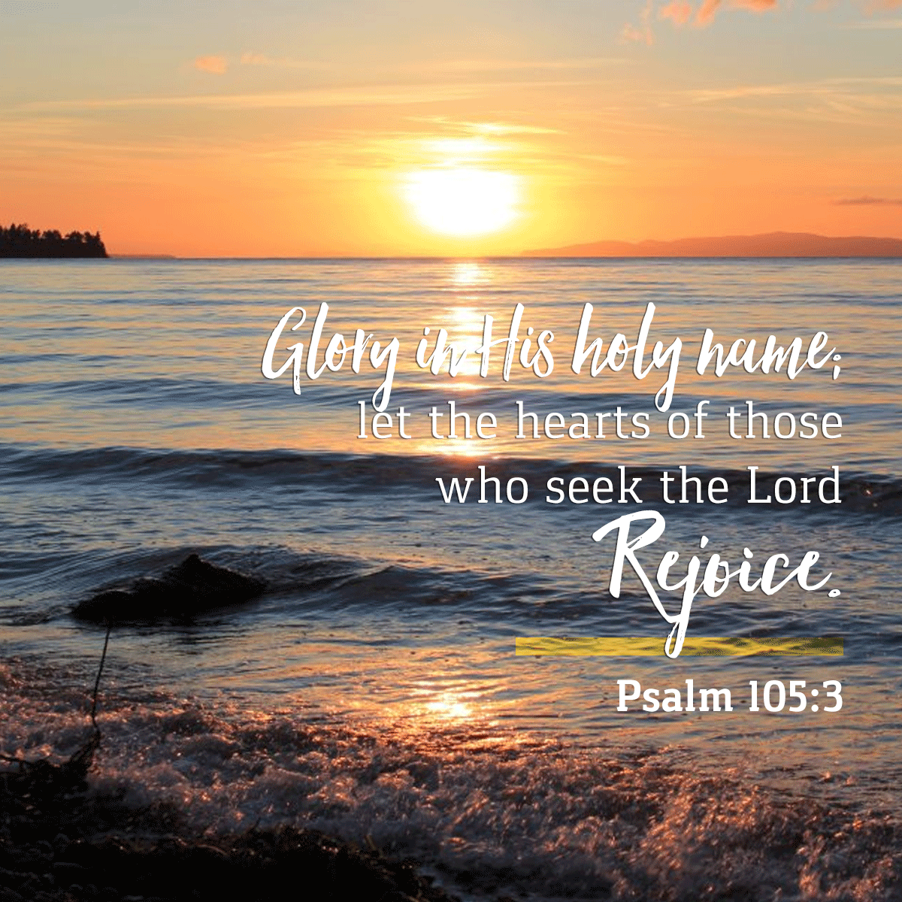
Haven United Methodist Church
Pastor ~ Juhee Lee
200 Taunton Avenue, East Providence, RI 02914
Phone: 401-438-4911/ Fax : 401-434-0289
www.havenumchurch.com ~ havenumchurch@yahoo.com
Pastor’s Office Hours: Mon, Tues & Sat - 10am–12pm and by appointment
Church Office Hours: Mon - Wed 9:30am-4:30pm, Thu. 9:30am-2:30pm

Morning Worship 9:30am July 26, 2020
Eighth Sunday after Pentecost

PRELUDE Aria Cesar Franck
GREETING
*MISSION STATEMENT: We are a haven for those who would seek to know God better while spreading the love of Jesus Christ.
*CALL TO WORSHIP Ministry Matters
L: Waiting is never easy for us.
P: We are a culture of “instant” response.
L: Today, God is asking us to wait; to be patient.
P: It is not going to be easy for us to do that.
L: Quiet your spirits and open your hearts to God’s word for you today.
P: Lord, be with us. Help us to be ready to hear and respond to your
word. AMEN.
*INVOCATION (in unison) Ministry Matters
God of surprising love, you have called us to be your treasures, to be those who love and serve you by helping meet the needs of others. Jesus reminded us that we were like mustard seeds that could grow into mighty shelters for those who felt abandoned; that we were like yeast placed in flour which causes the whole dough to rise and to be fruitful for the nourishment of God’s people, that we are also nets, cast into the unknown sea, gathering people for the Lord that they might be healed and saved. Give us courage and empower us to serve you boldly and joyfully, for it is in the healing love of Christ that we offer this prayer. AMEN.
*GLORIA PATRI
Glory be to the Father and to the Son and to the Holy Ghost;
As it was in the beginning, is now, and ever shall be,
World without end. Amen. Amen.
ANNOUNCEMENTS / CELEBRATIONS AND CONCERNS
HYMN “Spirit Song” UMH 347

PASTORAL PRAYER Pastor Juhee Lee
CHORAL RESPONSE TO PRAYER Hear Our Prayer, O Lord
Hear our prayer, O Lord, hear our prayer, O Lord;
Incline Thine ear to us, and grant us Thy peace. Amen.
A TIME FOR ALL GOD’S CHILDREN
WORSHIP IN GIVING With the Wings of Our Mind Music by Don-Whan Cho
Charlie Hartman, recorder & Beverly Rathbun, piano
*DOXOLOGY
Praise God, from whom all blessings flow; praise him, all creatures
Here below; praise him above, ye heavenly host; praise Father,
Son, and Holy Ghost. Amen.
OFFERTORY PRAYER Pastor Juhee Lee

SCRIPTURE
Epistle: Romans 8:26-39
SERMON Pastor Juhee Lee
*CLOSING HYMN “Sweet Hour of Prayer” v. 1 & 3 UMH 496

*BENEDICTION Pastor Juhee Lee
Our loving God knows our struggles and always be with us, especially in the midst of our weakness. Trust our almighty God who gives us courage, hope, peace and love through the work of Holy Spirit. Go forth with joyful heart to the world. May the blessing of God the Father, Son, and Holy Spirit be with you always. AMEN.
* Those that are able, please stand

