ANNOUNCEMENTS
Birthdays
Jayne Furze – 11/13 ~ Jim Hibbert – 11/21
COVID-19 CDC GUIDELINES – it is highly recommended that MASKS and SOCIAL DISTANCING continue as a precaution.
COFFEE HOUR – We need VOLUNTEERS to host Coffee Hour every Sunday. Please see Delores to sign up. For those weeks that no one volunteers, Coffee Hour will not happen.
HAND CHIME CHOIR – NO rehearsal after worship.
BISHOP’S DAY ON THE DISTRICT: Saturday, November 12th at 4:00pm. Haven has the honor of hosting Bishop Devadhar’s last Seacoast District Day before retiring on December 31, 2022. All are welcome!
UPCOMING MEETINGS:
Church Council – Thursday, November 17th @ 4:30pm in person.
HOMECOMING THANKSGIVING – Sunday, November 20th. Please, invite your family and friends!
THANKSGIVING BASKETS – Haven will be gifting 10 baskets with all the fixings for Thanksgiving to families in need. See Delores to sign up to donate.
CHRISTMAS CONCERT – Sunday, December 4th @3:00pm.
ANNUAL CHURCH CONFERENCE – Monday, December 5th @ 7:00pm via Zoom.
VISITATION/EMERGENCIES/NEEDS – If you would like a visit from Pastor Juhee, have an emergency, need, or concern contact the office or Pastor Juhee at 404-697-7496 or email leejuhee3@gmail.com.
PRAYER REQUESTS
Karen Miller and her son Austin Winkie Chrystie
Steve & Debbie’s granddaughter Alyson and son-in-law Mario
Ruth Sprigg Rev. Emmalou Kirchmeier
Kendra Perry Becky Cummins
George Erickson Lemuel Fuller
Ada Beebe Gloria Cady
Bob Macedo Romauld Paul
Joan Chase
Sharing your love and encouragement with them through cards or phone calls would be appreciated.
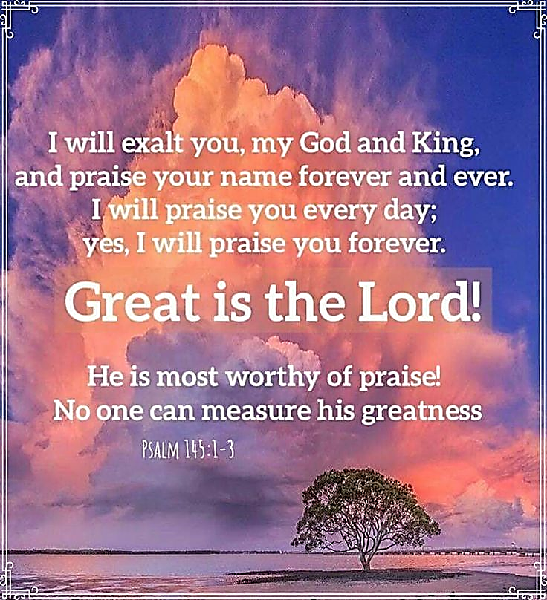

Haven United Methodist Church
Pastor ~ Rev. Juhee Lee
200 Taunton Avenue, East Providence, RI 02914
Phone: 401-438-4911/ Fax : 401-434-0289
www.havenumchurch.com ~ havenumchurch@yahoo.com
Pastor’s Office Hours: Mon, Tues & Sat - 10am–12pm and by appt.
Church Office Hours: Mon - Wed 9:30am-4:30pm, Thu. 9:30am-2:30pm
Morning Worship 9:30am November 6, 2022
Twenty-second Sunday after Pentecost

PRELUDE Sugie Jung
GREETING Manuel Fernandes
*MISSION STATEMENT: We are a haven for those who would seek to know God better while spreading the love of Jesus Christ.
*CALL TO WORSHIP Ministry Matters
L: The earth and all that is in it belongs to the Holy One.
P: Look, here is our God, for whom we have waited.
L: This is the Holy One, for whom we have waited.
P: Let us be glad and rejoice in our salvation.
L: Who shall ascend the hill of the Holy One? And who shall stand in this
holy place?
P: We come, seeking the face of God.
INVOCATION (in unison) Ministry Matters
We give you thanks, O God, for all the saints who have lived and died in faith and now rest in you. On this All Saints Day, we remember that we are not alone! We gather with the saints, who live in the presence of God, singing praises to the God of our salvation. We give you thanks, o God, for them whose lives were true blessing for our lives. They left their mark on the earth for you, for us, for our children to come. Thank you, God, for the tremendous sacrifices made by those who have gone before us. Bless the memories of your saints, God. May we learn how to walk wisely from their examples of faith, dedication, worship, and love. Strengthen us to follow their beacons until we meet at your heavenly banquet. In Jesus name we pray. AMEN.
*OPENING HYMN “Open My Eyes, That I May See” UMH 454
ANNOUNCEMENTS / CELEBRATIONS AND CONCERNS
*RESPONSE HYMN “Jesus, Remember Me” x3 UMH 488
PASTORAL PRAYER Rev. Juhee Lee
THE LORD’S PRAYER (in unison)
CHORAL RESPONSE TO PRAYER “Hear Our Prayer, O Lord”
Hear our prayer, O Lord; hear our prayer, O Lord;
Incline Thine ear to us, and grant us Thy peace. Amen.
VIRTUAL PASSING OF THE PEACE
L: The Peace of Christ be with you.
P: And also with you.
*HYMN “Shalom to You” UMH 666
A TIME FOR ALL GOD’S CHILDREN Rev. Juhee Lee
LITURGY FOR THE SAINTS - Lighting the Candles
A PRAYER MEDITATION FOR ALL SAINTS DAY
How shining and splendid are your gifts, O Lord which you give
us for our eternal well-being. Your glory shines radiantly in your
saints, O God in the honor and noble victory of the saints. The
white-robed company follow you, bright with their abundant faith;
Endowed with your everlasting grace, may we rejoice forever with
all the saints in our bright fatherland. O Christ, in your goodness,
grant to us the gracious heavenly realms of eternal life. In Jesus
name we pray. Amen.
WORSHIP IN GIVING “Savior, Like a Shepherd Lead Us” Sugie Jung
*DOXOLOGY
Praise God, from whom all blessings flow; praise him, all creatures here below; praise him above, ye heavenly host; praise Father, Son, and Holy Ghost. Amen.
*OFFERTORY PRAYER Rev. Juhee Lee
SCRIPTURE
Epistle: Ephesians 1:15-23
L: This is the Word of God for the people of God.
P: Thanks be to God!
SERMON “Apostle Paul’s Letter to the Ephesians” Rev. Juhee Lee
THE GREAT THANKSGIVING AND COMMUNION UMH 12
*CLOSING HYMN “'Tis So Sweet to Trust in Jesus” UMH 462
*BENEDICTION Rev. Juhee Lee
Ask help from the Holy Spirit to Know God more deeply. Be assured that God has called us to be saints for others in this world. Go in strength to be the saints of God and live the way that Jesus showed us with confidence. May the power of God our Creator, Christ our Salvation, and the communion of the Holy Spirit be with us now and forever. AMEN.
* Those that are able, please stand.
VISITORS: Please introduce yourself to Pastor Juhee. We are glad you were able to join us today!

