ANNOUNCEMENTS
WORSHIP SERVICES – view on our Facebook page!
COVID-19 CDC GUIDELINES – it is recommended that MASKS and SOCIAL DISTANCING continue as a precaution.
CHRISTMAS CONCERT – was a huge success!!! Thank you for your support! We raised $1350 for Healing Guatemala!
ANNUAL CHURCH CONFERENCE – went well (despite the weather!). Thank you to all who attended.
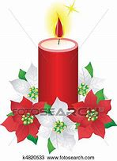
CHRISTMAS POINSETTIAS – In memory or honor of a loved one. TODAY is the last day to order. See Delores to order. $15/each. Choose RED or WHITE.
CHRISTMAS EVE CANDLELIGHT SERVICE – Friday, December 24th at 5pm.
ADVENT SPECIAL OFFERING – Waiting for Jesus coming, let us collect $1 per day until Christmas~!! It is $28.
HAVEN YOUTH BASKETBALL – Started November 3rd. Open to any youth in the community! Ages 8-12 practice from 5:00 to 6:30pm; 13-14 practice from 6:30 to 8:00pm; 15-17 practice from 8:00 to 9:30pm.
VISITATION – If you would like a visit from Pastor Juhee, let her know. Call Pastor Juhee at 404-697-7496 or email leejuhee3@gmail.com.
Birthdays
Joseph Thomas – 12/12 Ellie Pickering – 12/20
Jamie Connors – 12/20
Weekly PRAYER REQUESTS
Winkie Chrystie Jean James Kendra Perry
Rebecca Cummins Albert Weeden Rev. Althea Jackson
Lemuel Fuller Ruth Sprigg Karen Miller
Clarence Tucker Family of Bob Mason

CELEBRATIONS AND CONCERNS: Call the church office or talk to Pastor Juhee and tell us your Celebrations and Concerns. We will share them with the church family so that we can STAY CONNECTED!!

If you have an emergency or an immediate need, call the office at 401-438-4911 or Pastor Juhee at 404-697-7496. We are here to help!
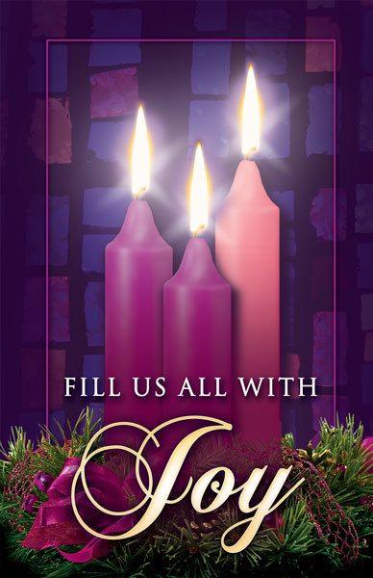
Haven United Methodist Church
Pastor ~ Juhee Lee
200 Taunton Avenue, East Providence, RI 02914
Phone: 401-438-4911/ Fax : 401-434-0289
www.havenumchurch.com ~ havenumchurch@yahoo.com
Pastor’s Office Hours: Mon, Tues & Sat - 10am–12pm and by appointment
Church Office Hours: Mon - Wed 9:30am-4:30pm, Thu. 9:30am-2:30pm

Morning Worship 9:30am December 12, 2021
Third Sunday of Advent

PRELUDE “Greensleeves” R. Vaughan Williams
GREETING Chris Barrett
*MISSION STATEMENT: We are a haven for those who would seek to know God better while spreading the love of Jesus Christ.
LIGHTING OF ADVENT CANDLE
*CALL TO WORSHIP Ministry Matters
L: The day foretold is coming,
P: When our bitter mouths will drink new wine, God's cup raised high
at the kingdom's table!
L: The one foretold is coming—
P: Whose bread will be broken in deepest gloom: a last supper shared
on a silent night!
L: The day is at hand!
P: World, feast!
L: The savior draws near!
P: Praise the Lord!
INVOCATION Ministry Matters
O God of the Coming One, we have come to draw water from your well. We trust; we will not be afraid, for you have promised that the taste of this water will not be bitter, like the tears of our eyes, but sweet, like the honey of flowers. From your well we will receive our baptism; from its waters we will accept our healing. All flesh shall gather here together, and the one who is lame shall leap for joy; the one who is outcast shall be brought in with gladness. O God, pour out your salvation upon us who thirst, and where once was shame there shall be only praise. AMEN.
*RESPONSE HYMN “We Bring the Sacrifice of Praise” 1x TFWS 2031
ANNOUNCEMENTS / CELEBRATIONS AND CONCERNS
HYMN “Alleluia” 1x UMH 186
PASTORAL PRAYER/THE LORD’S PRAYER Rev. Juhee Lee

CHORAL RESPONSE TO PRAYER ”Hear Our Prayer, O Lord”
Hear our prayer, O Lord; hear our prayer, O Lord;
Incline Thine ear to us, and grant us Thy peace. Amen.
VIRTUAL PASSING OF THE PEACE
L: The Peace of Christ be with you.
P: And also with you.
L: Let us radiate our light of love and peace toward each other.
HYMN “Shalom to You” UMH 666
A TIME FOR ALL GOD’S CHILDREN Rev. Juhee Lee
WORSHIP IN GIVING “Be Thou My Vision” v. 1, 3 UMH 451
*DOXOLOGY
Praise God, from whom all blessings flow; praise him, all creatures here below; praise him above, ye heavenly host; praise Father, Son, and Holy Ghost. Amen.
OFFERTORY PRAYER Rev. Juhee Lee
SCRIPTURE
Epistle: Philippians 4:4-7
L: This is the Word of God for the people of God.
P: Thanks be to God!
SERMON “Lighting the Light of Joy” Rev. Juhee Lee
*CLOSING HYMN “O Come, O Come, Emmanuel” v. 1, 4 UMH 211
*BENEDICTION Rev. Juhee Lee
The light of hope, love, joy, and peace come together to brighten up the dark world. Lighten a candle of joy with the flint of hope for the coming of the Lord. May the power of God our Creator, Christ our Salvation, and the communion of the Holy Spirit be with us now and forever. AMEN.

* Those that are able, please stand.
VISITORS: Please introduce yourself to Pastor Juhee. We are glad you were able to join us today!

