Haven United Methodist Church
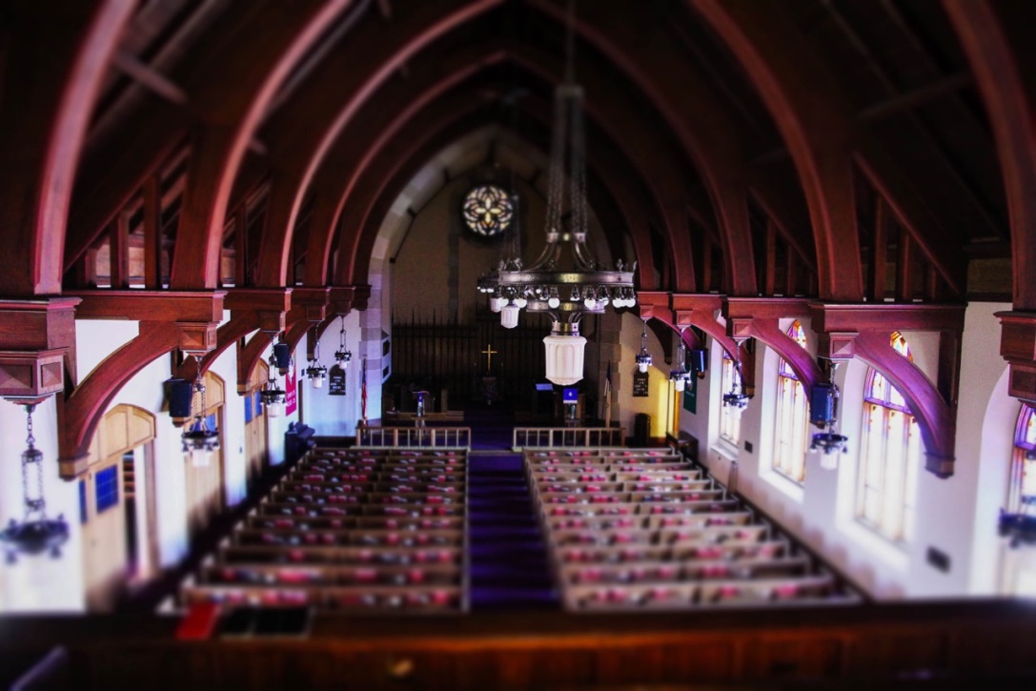

FACILITY USE

POLICIES & GUIDELINES

PACKAGE

Included:
- Application for Use of Church Facilities
- Worksheet for Assessing Facility Use Fees
- Hold Harmless Agreement
- Facility Use Policy – Non-church (Policies and Regulations
Regarding Use of Church Facilities by Non-church Groups)
Application for Use of Church Facilities
Name of Group/Individual: ________________________________________________________

Date of Application: _____________________________

Single Event Description of event: ________________________________________

Recurring use of specific rooms/areas for regularly scheduled program

Co-use of most/all church facilities (with terms to be determined)

Times Facilities Required: From: _______________ am/pm To: _______________ am/pm
(Circle) Monday Tuesday Wednesday Thursday Friday Saturday Sunday
Specific Date(s) Required: _______________________________________________________

Contact Person: ____________________________ Phone #: ___________________________

If there is a member of Haven United Methodist Church* who is also a member or associate of the applying group and who will accept responsibility for directing the proper use for the facilities, please note:

Church Member: ___________________________ Phone #: ___________________________

Use of HUMC facilities by any group or individual will require the execution of a Hold Harmless Agreement. Organized groups will also be required to submit of a certificate of insurance naming HUMC as an additional insured. The endorsement binder must be received before the date of use, with minimum liability limits of $500,000.

We have read and agree to comply with the “Policies and Regulations Regarding Use of Church Facilities by Non-church Groups.”**

Printed Name of Applicant: _______________________________________________________

Signature of Applicant: ___________________________________________________________

Address: ________________________________________________________________

Phone #: __________________________
FOR OFFICE USE ONLY

Approved: Yes No Date of Approval: _______________________

Rooms/areas to be used: __________________________________________________________

Donation Rec’d $ ___________________________ Receipt No.: ________________________
Note: Copy to be given to applicant after approval. Original application to be retained in the church files.
----------------------
*Hereafter referred to as HUMC
**The term “non-church group” refers to any group not sponsored by or related to HUMC
Worksheet for Assessing Facility Use Fees
- “Single event” is a one-time occurrence.
- “Recurring use” is for specific rooms/areas more than once a year for regularly scheduled
programs or activities.
- “Co-use” is for long-term, joint use of the facilities, equipment, and grounds between Haven
United Methodist Church and another approved group.
Single Event Recurring Use Co-use
Monthly total fee not to exceed
$700-900

Total fee determined by size of group and frequency of use

Co-use agreement allows use of all facilities, equipment, and grounds (except HUMC office areas)

Separate agreement required for each group
Sanctuary $250 $200

Chapel $150 $100

Gym $225 $200

Kitchen $75 $75

Nursery $35 $25

Hawksley Room/Kitchenette $175 $150

Asbury Room $175 $150

Carpenter Room $175 $150

Sunday School Room $125 $100

Classroom 1 $35 $25

Classroom 2 $35 $25

Classroom 3 $35 $25

Classroom 4 $35 $25

Classroom 5 $35 $25

Classroom 6 $35 $25

Classroom 7 $35 $25

Classroom 8 $40 $30

Custodial Fee (required) $65 $65

TOTAL $ $ $

Signature of HUMC:______________________________________

Date: ______________________________
Hold Harmless Agreement

I/We, the undersigned, in consideration of being allowed to use the property and facilities of Haven United Methodist Church at 200 Taunton Avenue in East Providence, RI, do hereby waive any and all claims, demands, and causes of action that we may have against HUMC as a result of the use of church facilities pursuant to this application. The applicant and the individuals executing this application shall indemnify and hold harmless HUMC and its officers, agents, and employees from and against any and all costs of litigation arising out of or associated with the use of church property by the applicant group and its members, guest, employees, and agents pursuant to this application.

Executed on this _______________________day of ___________________, 20______

Signed: _________________________________________________________________

On behalf of (organization): ________________________________________________

Key Deposit Policy

All non-church groups or individuals who are issued key/keys for use of the facilities at HUMC are required to provide a key deposit. Deposits must be paid not less than two (2) days before use of the facilities shall begin.

A deposit of $40.00 per key must be made. When keys are returned, all deposits will be refunded.

Key(s) accepted by: __________________________________________
Printed Name

__________________________________________
Signature

__________________________________________
Phone Number

Date: _________________________

Signature of HUMC: ____________________________________

Number of keys issued: (circle) 1 2 3 other ________

Deposit Amount: _________________________

Deposit refunded by: __________________________________________

Date: _________________________

Facility Use Policy—Non-church Groups

Policies and Regulations Regarding Use of Church Facilities by Non-church Groups

POLICIES
Haven United Methodist Church recognizes that providing its physical facilities in support of other compatible organizations and programs can increase our outreach and ministry in service to God and our community. At the same time, it is necessary that such use of facilities and equipment be managed in the best interest of the church. The intent of this statement is to establish consistent requirements for non-church group use of our church facilities.

All non-church groups (any group not sponsored by or related to HUMC) desiring to use church facilities must confirm acceptance of the terms herein specified. All required application forms must be completed and approved by the church. Further, donations must be received by the Office Administrator not less than two days before use of the facilities shall begin. An exception to this timeline is use of the facilities on a recurring or co-use basis, for which donations are due on the 1st of each month. Donations for use of our facilities may be paid in cash or by check. If a check is used, it shall be made out to Haven United Methodist Church. Renewal of permission to use stated church facilities depends, in part, on satisfactory compliance with requirements during the previous period of use. Groups that use the facilities on a year-round basis must renew their application each January 1st.

The Board of Trustees of HUMC reserves the right to accept or deny requests for use of church facilities and to cancel or modify established agreements in the church’s best interest regarding property management, requirements for use of the facilities for church activities (which shall always have priority), and church relationships with governmental regulations.

Requests for use of the facilities and/or equipment are to be processed through the church office. Requests will be honored on a first-come, first-serve basis as recorded on the church calendar. Reservations will be held for seven (7) calendar days, at which time a deposit of $50 must be paid. If the deposit is not paid within seven (7) days, the reservation is not considered firm and may be superseded. Regularly scheduled activities of HUMC have priority over all other requests.

TERMS
The terms “single event,” “recurring use,” and “co-use” are used throughout this policy package. “Single event” is defined as a one-time occurrence. “Recurring use” is defined as use of specific rooms/areas more than once a year for regularly scheduled programs or activities. “Co-use” is also referred to as “nesting.” It is a long-term agreement, renewed every year, and is defined as joint use of the facilities, equipment, grounds, etc., between HUMC and another approved group. A separate agreement is required for co-use, in order to address details such as schedule deconfliction.

REGULATIONS (updated on November 1, 2018)
1. All persons and groups desiring use of the church facilities and/or equipment for purposes that are not church related must sign an agreement with HUMC. The agreement acknowledges the group’s intent to abide by these policies and to accept responsibility for any damages to the facilities and/or equipment.

2. The objectives of the using group and the activities conducted on church property must not be in conflict with the mission and beliefs of this church.

3. Unless specific exception to this rule has been granted in writing by the governing body of the church, outside groups using church property or facilities may not charge a fee or receive monetary remuneration for services rendered on church property, except to defray:
a) Church usage fees
b) Instructional expenses for materials and leadership
c) Organizational dues or assessments to meet group operating expenses

4. Alcoholic beverages, liquors, and non-physician-prescribed drugs will not be permitted on church property or in church facilities at any time.

5. Smoking of any kind will not be permitted inside any church building. The smoking of legal substances only is permitted in the designated area behind the church.

6. Decorations used must be flameproof and shall not be attached to fixed portions of the facilities without specific approval in writing. The sanctuary may not be permanently decorated using any signs, symbols, etc., except as specifically approved by the Board of Trustees of HUMC. However, floral arrangements may be used. Decorations must not damage the facilities or furnishings in any way. The user group must remove all decorations when finished using the facilities.

7. Candles are not permitted unless for ceremonial use. If used, lit candles must be “dripless” and must not be placed on the keyboard or sound system. Lit candles must be placed on a plate or in a holder.

8. Building use hours are 8:00 am to 10:00 pm. Evening events will be concluded and the building closed by 10:00 pm, unless special arrangements have been made.

9. User groups will be responsible for leaving the facilities in a condition that is comfortable for the next using group. For example, all furniture and equipment must be returned to its customary position, the kitchen left in clean condition, dishes washed and put away, floors swept, waste baskets emptied with closed trash bags placed in the hallway outside of the room, etc.

10. The using group shall be held responsible for all loss or damage to church property during periods when they are using the facilities.

11. No facilities, equipment, furniture, or kitchen items shall be added, modified, loaned out, moved, or removed without prior approval from the HUMC Board of Trustees.

12. At no time shall equipment or facilities other than those covered by prior approval be used.

13. Permission to use church facilities or equipment shall not include liability on the part of the church for property damage or personal injuries resulting from user-group activities.

14. The communion table may not be used for any purpose other than its primary symbolic function.

15. Youth groups using the facility and/or equipment must have adequate adult supervision. All children on church property must be under adult supervision. Child/Adult ratios are as follows:
Ages 0-5 ~ 4 to 1; Ages 6-12 ~ 8:1; Ages 13+ ~ 12:1.

16. Use of the sound system, piano, electric piano and organ is permitted only under the supervision of persons authorized by HUMC. If a group has a long-term agreement for use of the church facilities, arrangements may be made for training select individuals. Only after proper training and certification by letter will select individuals be authorized to operate any of the above listed equipment.

17. At the inception of the use of facilities, user groups with a long-term co-use agreement will be required to give a key deposit of $40 per key. When a group terminates use of the facilities and all keys are returned, all deposits paid for keys will be returned. If the user group fails to return keys, the deposit shall be kept and transferred into the church general funds.

18. User groups with a long-term co-use agreement will be given training by a member of HUMC on how to properly open, close and secure the facilities.

FEES
All persons/groups approved for use of church facilities are required to pay applicable fees, as stated in this policy package. Any discount or waiver granted represents an assumption of these fees by HUMC in support of the activities of the user groups.

The church facility is available at no charge to members/constituents and their immediate families for funerals and family celebrations, such as anniversaries. However, a custodial fee may be required. Requests for such usage should be made following reservation procedures, as stated in this policy document. Also, as a community service, the church facility is available to non-members for funerals at a reduced rate and for weddings for the fees listed in the Wedding Packet. For funerals, non-members will be charged fees listed under "recurring use" on the "Worksheet for Assessing Facility Use Fees." This does not include the fee for the services of the pastor, which should be arranged directly with the pastor.

All fees are for usage up to six (6) hours. After 6 hours, an additional fee of $25 per hour is charged.

A deposit of 25% (less the $50 Reservation Deposit) is required at the time the reservation is confirmed, with the balance due no less than 2 days before use.

Current facility use fees are stated in the “Worksheet for Assessing Facility Use Fees,” found in this package.

If further information or clarification is needed, individuals should contact the Office Administrator at Haven United Methodist Church at 401-438-4911 or by email at havenumchurch@yahoo.com.

